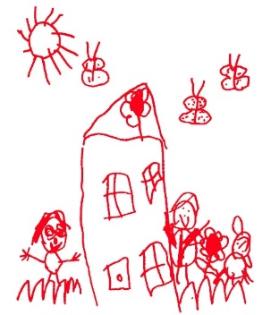

HOME LEARNING – Alphabet Workout

Looking for ways to get the family active? Why not try the Alphabet workout!
You can create your own alphabet workout with lots of fun activities or use our list. You could also start at A and work your way through the alphabet together! You can also get creative and spell your name, other family members names, your street, the list is endless.
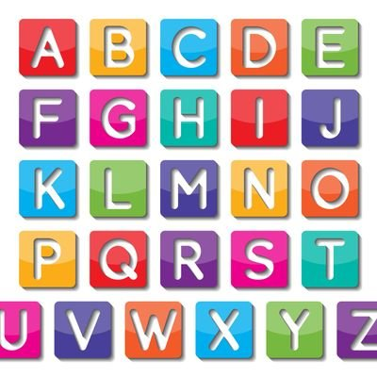
A – Jump up and down 20 times
B - Run to your bedroom and back
C - Hop on one leg 10 times then swap to the other
D – Dig like a dog for 30 seconds
E- Touch the ground and then jump up 10 times
F - 10 push ups
G - Make a bridge shape on the floor for 20 seconds
H - Balance on one foot for 20 seconds then the other
I - 20 Star jumps
J - Frog hop 10 times
K - Kangaroo jump around the house
L - Run on the spot for 30 seconds
M - Imagine you’re an animal and move like it for 30 seconds
N -Crab walk across the room and back
O - Plank for 30 seconds
P - Move sideways across the room and back 5 times
R – Rabbit hop to your room and back
S - Spider man walk on the ground across the room
T - Crawl around the room on all 4s for 1 minutes
U - Walk backwards across the room and back
V - 20 jumps on the spot
W - Crab walk to the next room
X - Run with your knees up high on the spot-40 times
Y - Balance on one leg for 20 seconds
Z - Jump on the spot 20 times

